STEP 1: Create your new email signature

FIRST NAME LAST NAME Job Title
BREAKTHRU BEVERAGE GROUP
O 555.555.5555 M 555.555.5555
Street Address | City, State Zip Code
BreakthruBev.com
Please note my new email address

- Following the above template, insert your name and title
- If you are market-based, Add your market (e.g. BREAKTHRU BEVERAGE FLORIDA , or, if you are Corporate or non-market based Add GROUP (e.g. BREAKTHRU BEVERAGE GROUP)
- Add your office and mobile phone (if you prefer NOT to include your mobile number, delete that section)
- Add your office address
- Highlight and Copy the entire template (including the Spear)

STEP 2: Create a New Email Signature in Outlook
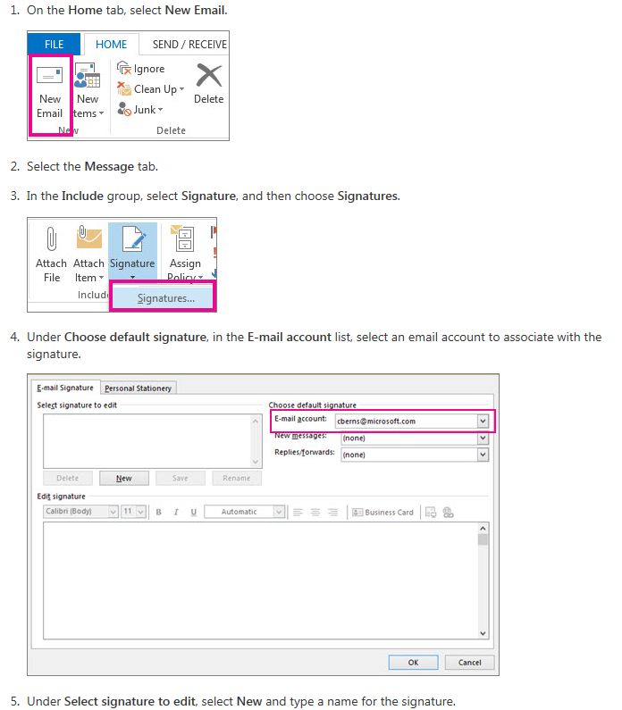
- Under Edit signature, PASTE the copied image of your email signature (copied from the word file) and Select OK.
- Exit Outlook and restart to recognize the new signature file.

